CSS 475 A Database Systems

Homework 2 (30 possible points) [6% of final grade]

Submit: to Canvas

Due BY: April 22 (Sunday) 11:59 PM
1. (8 points) Design an ER diagram for keeping track of information about votes taken in the U.S. House of Representatives during the current two-year congressional session. The database needs to keep track of each U.S. state’s name (e.g., ‘Texas’, ‘New York’, ‘California’) and include the region of the state (whose domain is {‘Northeast’, ‘Midwest’, ‘Southeast’, ‘Southwest’, ‘West’}). Each congress person in the House of Representative is described by his or her name, plus the district represented, the start date when the congressperson was first elected, and the political party to which he or she belongs (whose domain is {‘Republican’, ‘Democrat’, “Independent’, ‘Other’}). The database keeps track of each bill (i.e., proposed law), including the bill name, the date of vote on the bill, whether the bill passed or failed (whose domain is {‘Yes’, ‘No’}), and the sponsor (the congressperson(s) who sponsored – that is, proposed – the bill). The database also keeps track of how each congressperson voted on each bill (domain of vote attribute is {‘Yes’, ‘No’, ‘Abstain’, ‘Absent’}).
Additional information:
- There are 435 congresspersons in the U.S. House of Representatives.
- States have between one and 52 representatives.
- M represents number of bills during the 2-year session.
Draw an ER diagram for this application. Be sure to indicate the various attributes of each entity and relationship set; also specify the key and structural constraints for each relationship set. If you make any assumptions beyond everything stated above, explain clearly in your submission.
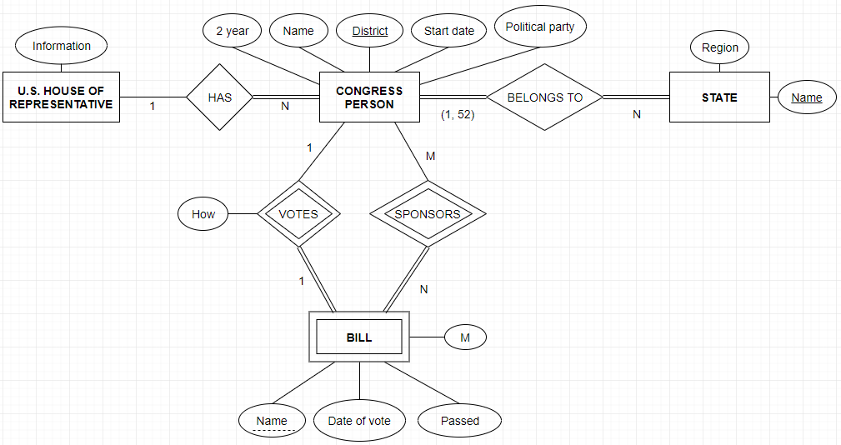
2. (3 points) Consider the ER diagram in Figure 1. Assume that an employee may work in up to two departments or may not be assigned to any department. Assume that each department must have one and may have up to three phone numbers. Additionally we have the following additional assumptions:
Each department can have anywhere between 1 and 10 employees.
Each phone is used by one, and only one, department.
Each phone is assigned to at least one employee, and may be assigned to up to 10 employees.
Each employee is assigned at least one, but no more than 6 phones.
Supply (min, max) constraints on this diagram. If you make any assumptions beyond everything stated above, explain clearly in your submission.

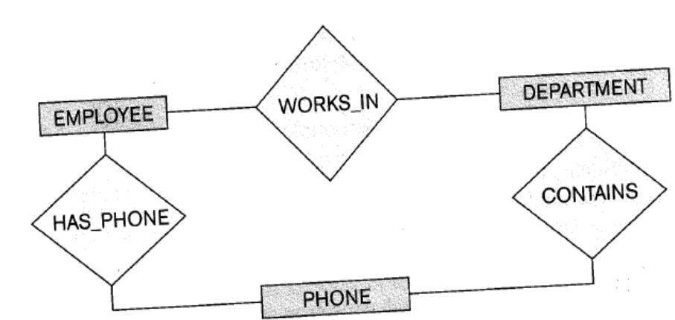
Figure 1
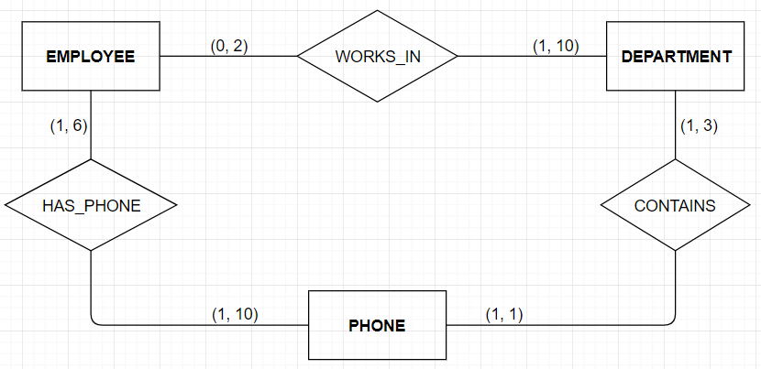

3. (5 points) Suppose that each of the following update operations is applied directly to the database shown in Figure 2. Discuss all schema-based constraints violated by each operation, if any, and at least 2 different ways to solve such issues (so that no constraint is violated).
- Insert <Robert', 'F', 'Scott', '943775543', '1972-06-21', '2365 Newcastle Rd, Bellaire, TX', M, 58000, '888665555',1> into EMPLOYEE.
This insertion satisfies all constraints, so it is acceptable.

- Insert <'ProductA', 4, 'Bellaire', 2> into PROJECT.
This insertion violates the referential integrity constraint because there is no 2 which is Dnumber in DEPARTMENT. The first way to solve this violation is that insert data to available Dnum, and the other way is that insert new data into DEPARTMENT.
1.Insert <'ProductA', 4, 'Bellaire', 5> into PROJECT.
2.Insert <'Product', 2, '666884444', ‘2000-04-17’> into DEPARTMENT.

- Insert <'Production', 4, '943775543', '2007-10-01'> into DEPARTMENT.
This insertion violates the key constraint because 4 which is Dnumber already exists in DEPARTMENT, and it violates there is no person whose ssn is ‘943775543’ in EMPLOYEE in Figure 2. To solve this violation, it should be inserted new data into EMPLOYEE, or both Mgr_ssn and Dnumber should be changed by new data.
1.Insert <’Robert', 'F', 'Scott', '943775543', '1972-06-21', '2365 Newcastle Rd, Bellaire, TX', M, 58000, '888665555',1> into EMPLOYEE.
1.Insert <'Production', 2, '943775543', '2007-10-01'> into DEPARTMENT.
2. Insert <'Production', 2, '666884444', '2007-10-01'> into DEPARTMENT.

- Insert <'677678989', NULL, '40.0'> into WORKS_ON.
This insertion violates the entity integrity constraint because Pno is a primary key in WORKS_ON, so it must not NULL. Also, there is no employee whose ssn is ‘677678989’, so it violates the referential integrity constraint. To solve this violation is that insert a valid Pno and insert new data into EMPLOYEE. Another way is that insert an existing ssn and valid Pno.
1.Insert <’Cruise', 'W', 'Tom', '677678989', '1972-06-21', '2365 Newcastle Rd, Bellaire, TX', M, 58000, '888665555',1> into EMPLOYEE.
1.Insert <'677678989', 3, '40.0'> into WORKS_ON.
2.Insert <'666884444', 1, '40.0'> into WORKS_ON.

- Insert <'453453453', 'John', M, '1990-12-12', 'spouse'> into DEPENDENT.
This insertion satisfies all constraints, so it is acceptable.

- Delete the WORKS_ON tuples with Essn = '333445555'.
This deletion will cause the referential integrity constraint because the employee whose ssn is ‘333445555’ works on four different projects, so if it is deleted, other employees working hours also are changed. The first option is restrict is to reject the deletion, and the second way to solve this deletion is that called cascade is to attempt to cascade the deletion.
    - Restrict
    - Cascade

- Delete the EMPLOYEE tuple with Ssn = '987654321'.
This deletion violates the referential integrity constraint because the person whose ssn is '987654321' is a manager of the administration department, and the person works on two projects. Also, the person has a spouse in DEPENDENT, so this person relates more than one tuples. Thus, the first way is called restrict is to reject the deletion, and the second option is called cascade is to attempt to cascade the deletion.
    - Restrict
    - Cascade

- Delete the PROJECT tuple with Pname = 'ProductX'.
This deletion is the referential integrity constraint because there are some employees who works for ProdectX which Pno is 1 in WORKS_ON. To avoid the constraint, the first option is that called cascade, and the other way is that called set default to modify the referencing attribute values.
    - Cascade
    - Set default

- Modify the Mgr_ssn and Mgr_start_date of the DEPARTMENT tuple with Dnumber = 5 to '123456789' and '2007-10-01', respectively.
This modification violates the referential integrity constraint because if it is updated, the Super_ssn for the employee must be changed too, and the Dno = ‘5’ that ssn = ‘333445555’ in EMPLOYEE must change to Dno = ‘1’. The other option is set null because they are not primary keys in the DEPARTMENT.
1.Modify the Super_ssn of the EMPLOYEE tuple with Ssn = ‘123456789’ to '888665555', respectively.
1.Modify the Dno of the EMPLOYEE tuple with Ssn = ‘333445555’ to ‘1’.
2.Set null

- Modify the Super_ssn attribute of the EMPLOYEE tuple with Ssn = '999887777' to '943775543'.
The modification violates the referential integrity constraint because there is no employee whose ssn is ‘943775543’ in Figure 2. The first option is that modify a valid Super_ssn, and another way is set null because it is not a primary key in the EMPLOYEE.
    - Modify the Super_ssn and Dno attributes of the EMPLOYEE tuple with Ssn = '999887777' to '333445555' and 5.
    - Set null

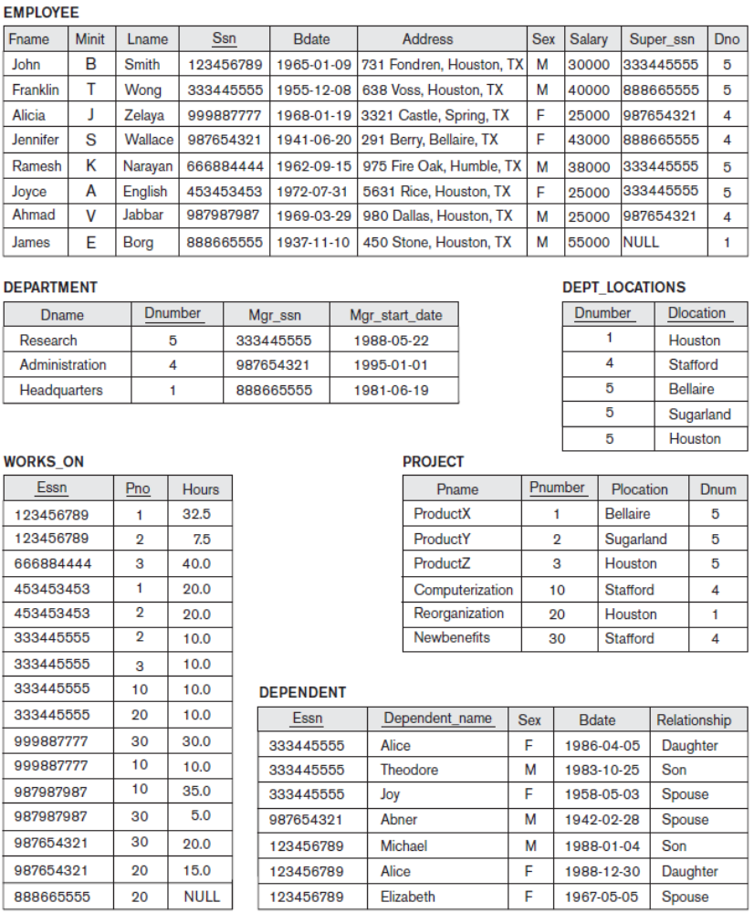
Figure 2

4. (7 points) Try to map the relational schema of Figure 3 into an ER diagram. This is part of a process known as reverse engineering, where a conceptual schema is created for an existing implemented database. State any assumptions you make.
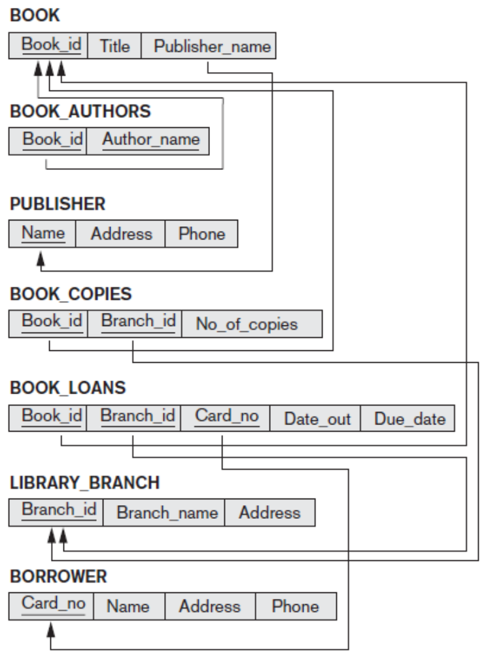
Figure 3
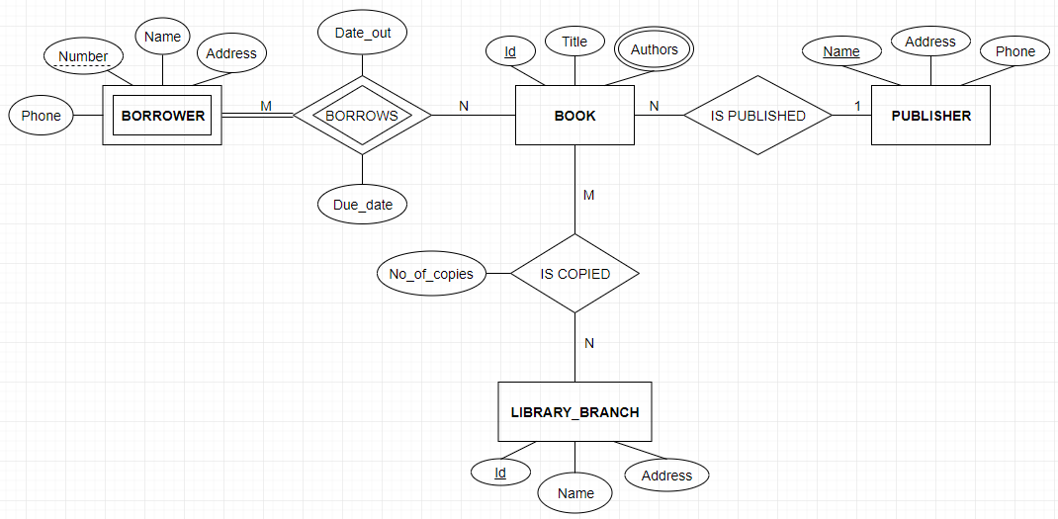
5. (7 points) Figure 4 shows an ER diagram for a database that can be used to keep track of transport ships and their locations for maritime authorities. Map this schema into a relational schema, and specify all primary keys and foreign keys.

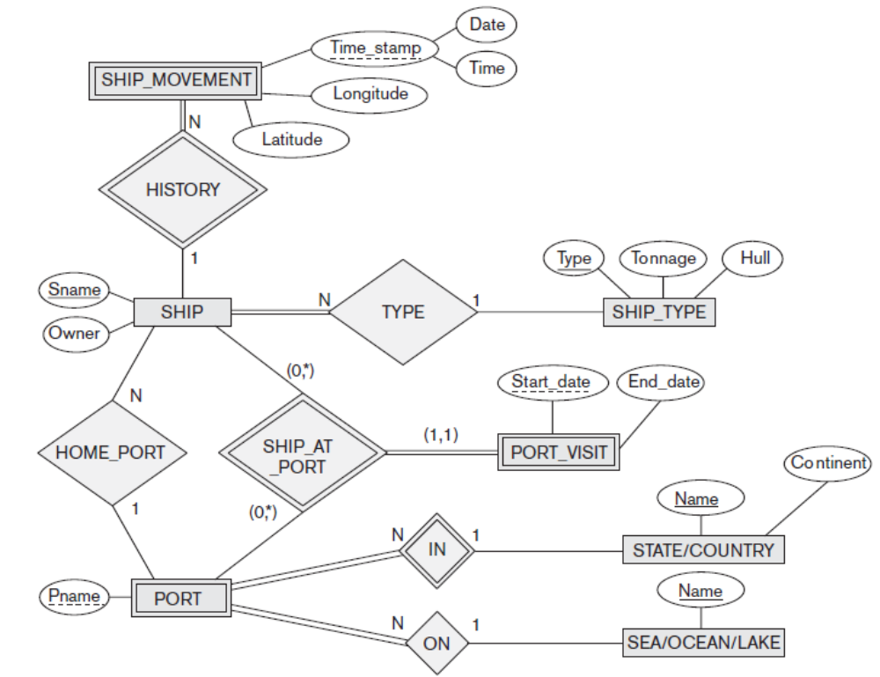
Figure 4
